<Company> Systems, Inc.

Intelligent Automation

Change Management

Confidential

Table of Contents

Introduction 3

Sources of RPA Change 3

Business Process Change 3

Non-Functional Bot Software Changes 3

Intelligent Automation Infrastructure Changes 4

Application Change: Calibration 4

Change Management in the Intelligent Automation Life-cycle 4

Types of Change 5

Key Change Management Roles & Activities 6

Post Implementation Review of Change 7

Communication of Change 8

Integrating other Intelligent Automation Technologies 8

Appendix A – Change Register Management Checklist 9

# Introduction

RPA and other Intelligent Automation deployments require systematic change management to ensure any changes to deployed automations and related IT infrastructure are authorized and verified so as to avoid disruptions. This will ensure that any interruption in business processes are kept to a minimum. The Intelligent Automation COE plans and communicates the implementation steps, keeping in mind the urgency of change and its potential business impacts. The Change Manager and (for further-reaching Changes) the Change Advisory Board (CAB) are responsible for managing and delivering changes. Urgent changes are handled through an appropriately staffed Emergency Change committee (EC) with appropriate authority to make change decisions in an emergency.

It is recommended that the Intelligent Automation Change Management approach is aligned with <Company>’s Change Management process and SLAs to avoid any process related confusion.

# Sources of RPA Change

As with other changes in IT software and infrastructure deployments, changes to RPA deployments can arise from both business users and IT infrastructure needs in following ways:

1. Business Process Change
2. Non-functional Bot Software Changes
3. Intelligent Automation Infrastructure Changes
4. System or Application Changes

Changes could also be a combination of above and the Intelligent Automation COE should analyse proposed changes in totality to understand true implications and classification of change.

The change management process excludes changes that happen during development lifecycle. Such changes have to be handled within the purview of the Bot Development Lifecycle (please refer to guidelines on Bot Development Lifecycle).

## Business Process Change

RPA and other Intelligent Automation technologies are used to depict business process logic and steps. In the event that evolving business needs require these process steps need to be changed, the Business Process Owner will raise the Request for Change to <Company>’s Intelligent Automation COE.

These changes may also involve embellishment of functionality such as handling of exceptions, errors or multiple situations to existing Bots that are in production. Howsoever minor such changes may seem, in the interest of good software development practices, traceability and continued stability of the specific process and the complete automation infrastructure, it is vital that all such changes be tracked as part of the change management process.

## Non-Functional Bot Software Changes

Non-functional changes are initiated typically by COE IT implementation or management teams who constantly monitor each automation individually and as a portfolio for technical performance, technical suitability and design of Bot script and/or technical solution. Such change requests do not seek to alter the business logic and process steps as is the nature of functionality. Non-functional change requirements may be discovered as a consequence of business requests or support tickets also when the support teams have time to deeply analyse specific issues and aspects of each automation. Non-functional changes to Bots may also arise from upgrade, new versions to the product(s) on which RPA and other technologies are deployed.

## Intelligent Automation Infrastructure Changes

Change requests may also arise from need to make alterations in the infrastructure on which Bots are deployed. Infrastructure changes can also necessitate need for upgrade to hardware or software as per <Company> compliance requirements from time to time. In planning for such changes, it is important to consider downtime implications to minimize the impact on the Business, where Bots are running on targeted Infrastructure. For the case of RPA deployments infrastructure change has been separated out of software related Bot changes. This approach will bring clarity to handling of the change.

## Application Change: Calibration

Much of RPA works off the GUI/front-end of applications and depends on the controls and fields on user screens. In case of changes to any such objects, controls and fields including their location on the GUI, the Bot can likely be impacted. In case of such changes to applications, the COE IT team should monitor and assess for any impacts on existing automations in production on a routine basis. Such monitoring is part of the routine operation of the COE IT management & operations team. If it is determined that any application change will impact process/Bots in production, they shall raise a change request to the COE Change Manager to assess and prioritize the change.

# Change Management in the Intelligent Automation Life-cycle

Change Management is a key element to complete the overall Intelligent Automation Life-cycle. It is inevitable that deployed automations will require changes of either a functional or a technical nature. Therefore, particular attention should be paid and sufficient procedure and capacity be planned to requests for change to deployed automations.

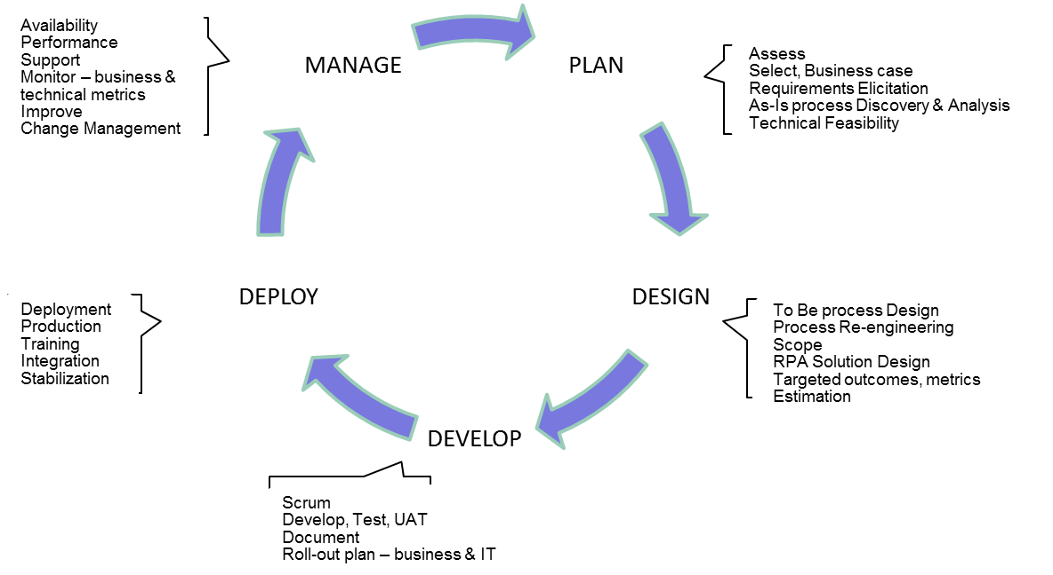

Change Management Process

Once Request for Change has been initiated, it will follow the assessment, discovery and development process as depicted below. The process depicts the standard approach of: Review, Classification, Authorization, Planning and Implementation for Change Management.

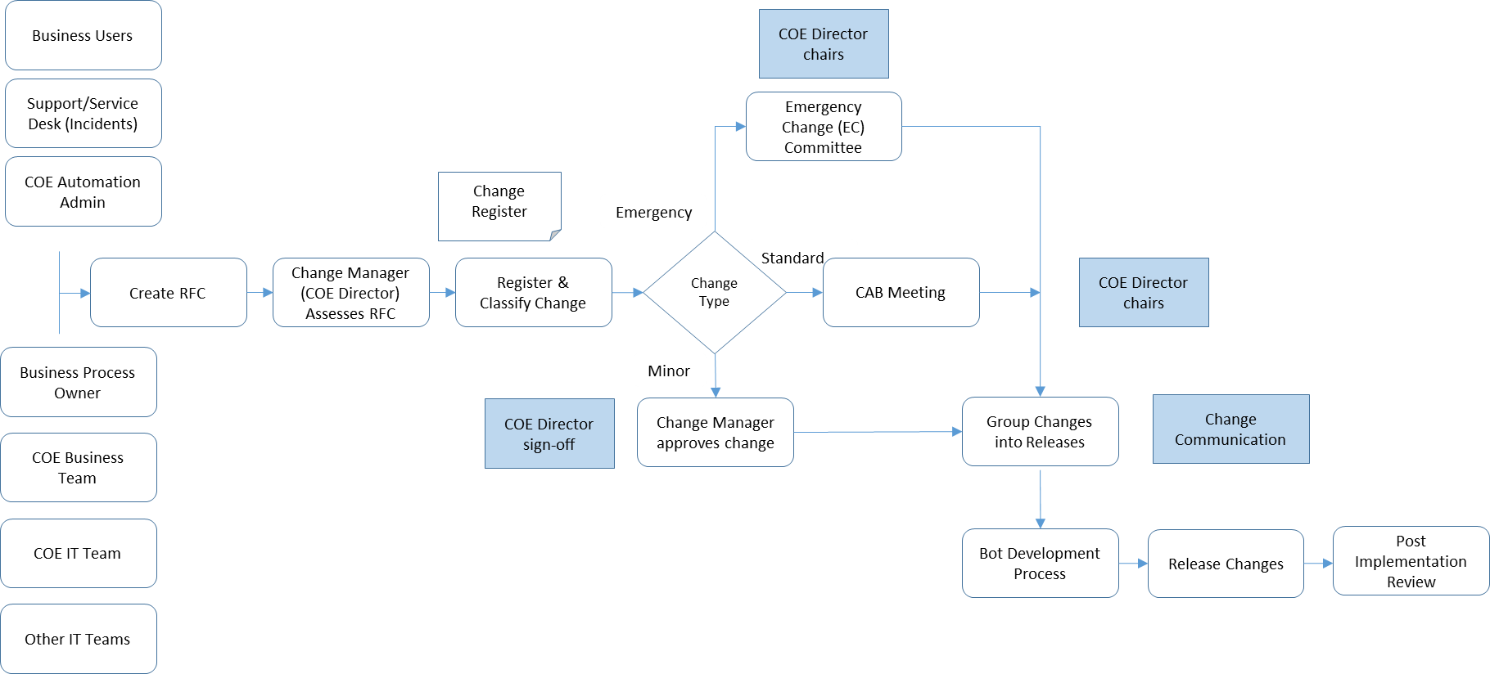

# Types of Change

To keep change management simple it is recommend that a simple classification criteria be followed.

Emergency Change:

Change requirements that meet highest severity and urgency classification as per <Company> IT Support Guidelines.

Standard Change:

Change requirements that are not highest severity and urgency as per <Company> IT Support Guidelines. However, these changes are assessed as requiring significant change to business processes and/or considerable outlay of resources to complete and put into production.

Any changes that impact end customers or employees (where employees are internal customers: such as employee related HR, Payroll, Finance, compliance processes) of <Company> MUST be in this category or under Emergency Change category.

All upgrades to targeted applications where Bots are performing operations and need to Bots to be upgraded would also be classified as Standard Changes.

Minor Changes:

Changes that do not fall into above two categories and involve less than 2 days of development work with no major change to business processes or business process owner approvals fall into this category. Any changes that impact end customers or employees (where employees are internal customers: such as employee related HR, Payroll, Finance, compliance processes) of <Company> cannot be in this category.

# Key Change Management Roles & Activities

Following roles are key in overseeing the change management process and ensuring delivery of changes. The Director COE and COE team play a key role in assessment, management and release of change and aligning development efforts for change requests with Scrum Team priorities.

Change Manager

Controls the lifecycle of any requested changes and manages the risks involved, to avoid service disruptions. Classifies each change request into Minor, Standard, and Emergency Change. It is to be ensured, that only [RFC](https://wiki.en.it-processmaps.com/index.php/ITIL_Glossary#Request_for_Change_.28RFC.29) which are in accordance with the defined quality requirements are accepted into the Change Management Process. Change Manager works closely with the Director COE to ensure the latter is kept abreast of all changes via an updated Change Register.

Business Process Owner

The Business Process Owner is the primary stakeholder in the change management process. Severity, solution approach and delivery timelines are signed-off by the Business Process Owner. He must be part of the CAB and EC and kept abreast of all relevant communication and milestones with regard to the change.

Business SME

The Business SME provides required process depth to the Change Manager and change management team to understand the process in the context of the planned change. Business SME is nominated by the Business Process Owner and is required as the latter may not have all finer process details available for the Change Management team. Business SME is responsible for validating the facts, process logic and business impacts and for assisting the change management and development team to finalize the planned changes. In Emergency Change situations, it is vital that the Business SME makes themselves available to meet urgent requirements.

Change Advisory Board (CAB):

The CAB advises the Change Manager (Director COE or designated COE Manager) in the assessment, prioritization and scheduling of changes. It is chaired by the Director COE and other recommended CAB members are Business Process Owner, Support Manager, COE Application Owner. Other members may be included by Change Manager based on nature of change and requirement for additional inputs. These may include Business SME (nominated by Business Process Owner), other <Company> IT team members from Application and/or Infrastructure side as required.

Emergency Committee (EC):

The Emergency Committee represents the body for the approval of changes in emergencies which, due to their urgency, do not allow a full CAB review process. It is convened by the Director COE for emergencies/highest severity levels. It is chaired by the Director COE and other recommended EC members are Business Process Owner, Support Manager, COE Application Owner. To ensure that the EC is definitely in a position to act decisively in an emergency, rules for availability and temporary replacements of members must be maintained by the COE Director. EC (Director COE) must update the CAB with details regarding the emergency change to ensure the Change Management stakeholders stay in sync and to avoid disruptions in future associated changes.

Key Change Management Roles for Intelligent Automation:

|  |  |
| --- | --- |
| Change Mgmt Activity/Role | <Company> Personas |
| Change Initiator | Business Process, Support, <Company> IT Teams, COE Business Team, COE IT Teams, others |
| Change Manager | Director COE or Assigned COE Manager  Director COE needs to be involved in all RPA Change Discussions |
| Change Advisory Board | Director COE, Business Process Owner, Support Manager, COE Application Owner |
| Emergency Change Committee | Director COE, Business Process Owner, Support Manager, COE Application Owner |
| Configuration & Release Manager | COE Application Owner |
| Change Delivery | COE Manager or other assigned resource by Director COE |
| Change Communication & Integration | COE Manager |

# Post Implementation Review of Change

After release and stabilization of the change in production, Change Manager (Director COE or designated COE Manager) conducts a review of the Change Management process and the results of the Change-implementation. This is logged in the Change Register or Incident Management Tool, and provides a reference for best-practices and lessons that may be learnt for improving handling of future changes.

# Communication of Change

The Intelligent Automation COE is responsible for communicating the status of each change request to all stakeholders. This enables Business Process Owners, Support Team, COE IT teams and <Company> IT teams to plan accordingly and eases the integration of the change.

# Integrating other Intelligent Automation Technologies

While this document focuses on the RPA enabled automation deployments, it should be kept in mind that Intelligent Automation deployments may involve multiple other technologies including AI, ML, OCR, ChatBots or other specialized technology components. The COE Manager in their planning should ensure that all such Application Owners or other Technical Leads from each such area is included into the Change Management process as per needs of the change request.

# Appendix A – Change Register Management Checklist

The Change Register should capture following information that tracks the history of the change request from initiation. It should be available and tracked in a highly available tool such as in Azure DevOps or Support Portal for ease of availability to all concerned.

Entry by Change Initiator:

* Change ID (Unique)
* Change Initiator
* Process SME (Primary contact for further discovery of process & impacts)
* Business Process Owner
* Date of submission
* Short description of the Change being applied for
* Reason for the Change to be implemented (Benefits, Risks: Why is change reqd; Business Case)
* Priority & Severity (urgency)
* Time-line for change implementation

Entry/Update by Change Manager:

* Change Manager may update above fields created by the Change Initiator/Requestor based on further assessment and discovery of need. Change Manager shall consult the CAB, EC and development team experts to complete following areas for tracking change related information:
* Resources required for implementation of change
  + Required personnel resources (from which areas?)
  + Estimated work effort
  + Cost estimate
  + Statement as to whether the costs are included in the planning of the budget
* Impacts on:
  + Business
  + COE IT
  + <Company> IT Infrastructure
* Risks during the implementation of the Change
  + Types of risk
  + Risk mitigation (e.g. reversion procedure)
  + Fall back plan/workaround
* Constraints
* History of events
  + Date of submission of the RFC
  + Date of the receipt of the RFC by the Change Manager
  + Date of the acceptance or rejection of the RFC
  + Date of the clearance or rejection of the Change
  + Date of release of change production
* History of decisions
  + Person/ body in charge for the decision about clearance/rejection (Change Manager/ CAB/ EC)
  + Where necessary, the reason for the rejection of the Change by the Change Manager/ CAB/ EC
* Post implementation review